1. We’re navigating to the home page by clicking the search link (Since the tag name was “a”) on the top left, so Instead of Search it should be Home

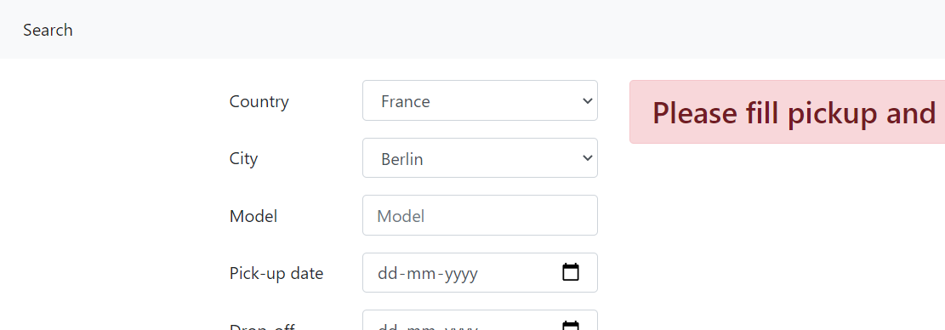

1. We can able to Select any City for example I can Select a Country such as France and City such as Berlin, but Berlin is not in France. If I Select France, cities in France alone are visible or throw an error while clicking the search button.
2. We can able to Select the previous dates for Pickup and drop-off, the previous date should not be selectable or an error needs to be thrown after clicking the search button.
3. After Clicking the Search button available cars were displayed. Sometimes after clicking the rent button we get the below Exception.

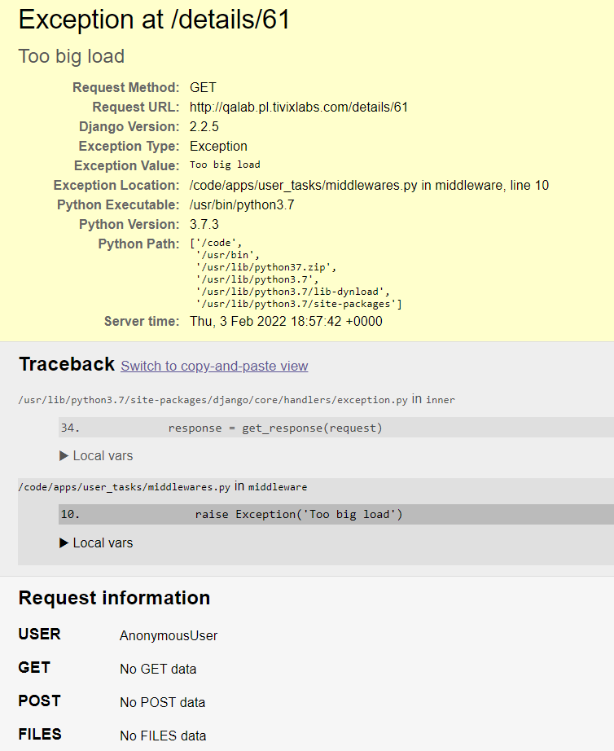

1. In Some cases Rent button is not visible on the car details page.
2. Got a 404 error after clicking the rent button on the Summary page.

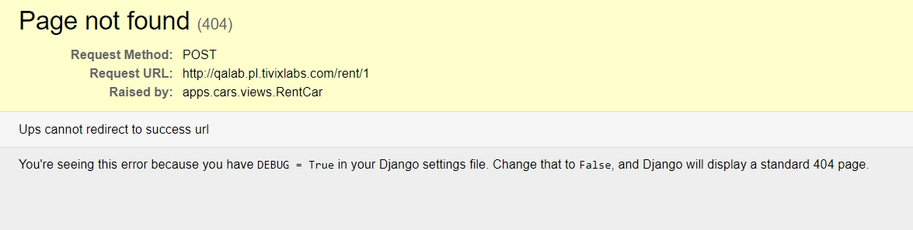

1. Car Model is not Filter in the Rental cars List. If we give “Mazda 3” and Search cars, other model cars were also available
2. Car model is not listed on the Summary page
3. Can able to enter numbers in First name and last name on the Summary page. No error was thrown after clicking the Rent button

